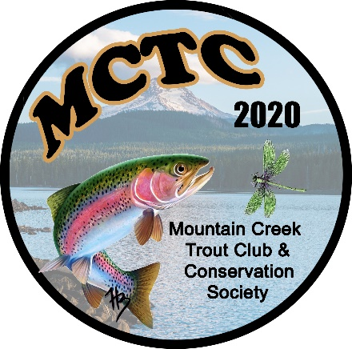
Mountain Creek Trout Club and Conservation Society
Email: MCTCACS@outlook.com
Web: mountaincreektroutclub.com

SPONSORSHIP PACKAGES
We are looking for sponsors to support our organization’s mission to improve the Mountain Creek.
Any and all donations are greatly appreciated.

$500 Platinum
Ad in our triannual newsletter
Logo/name on our banner that will be displayed at all of our events
Logo/name on our website (includes a link to your website)
$300 Gold
Ad in our triannual newsletter
Logo/name on our banner that will be displayed at all of our events
$150 Silver
Logo/name on our banner that will be displayed at all of our events
Donation
An amount or gift of your choice to be used for _____ tagged fish or _____ Rubber Duck race prizes

Donation Amount $ _______
Business Name: ___________________________________________
Owners Name: ____________________________________________
Business Address: __________________________________________
City: ________________________ State: ______ Zip: __________
Phone : ( ) _______ - ___________
Email : ________________________________________________

All donations are tax deductible
Please make checks payable to: Mountain Creek Trout Club
Donations and forms can be mailed to: Mountain Creek Trout Club
400 High Mountain Rd, Shippensburg, PA 17257
Sponsorships effective from January 1 to December 31 of each calendar year

